Create the instance install java git maven tomcat on it. Got to the jenkins interface and integrate git server with jenkins for webhooks concept.go to system then github server add server and copy the access token of git as secret text.

Then go to the git repos and create the webhooks for each repo.

1.created the job for the repo1 also created and added webhooks for the repo1.

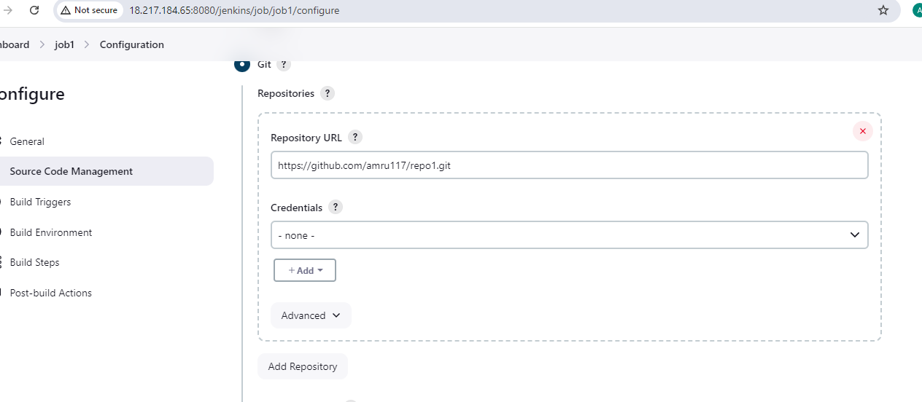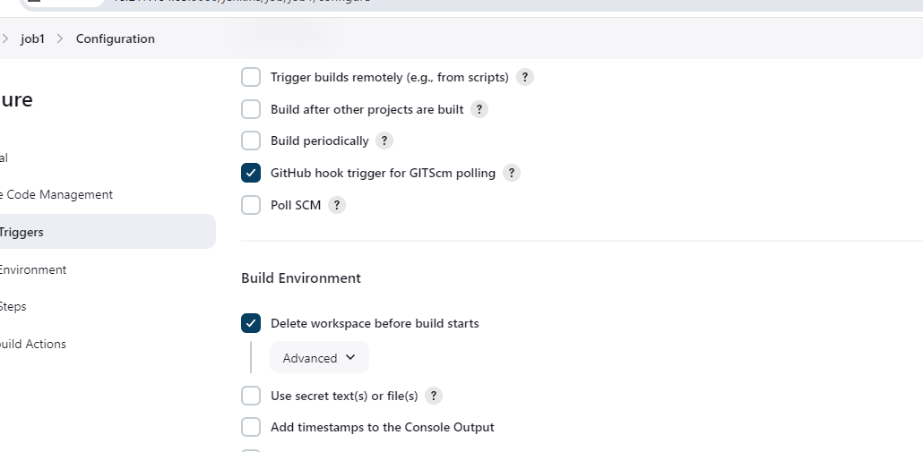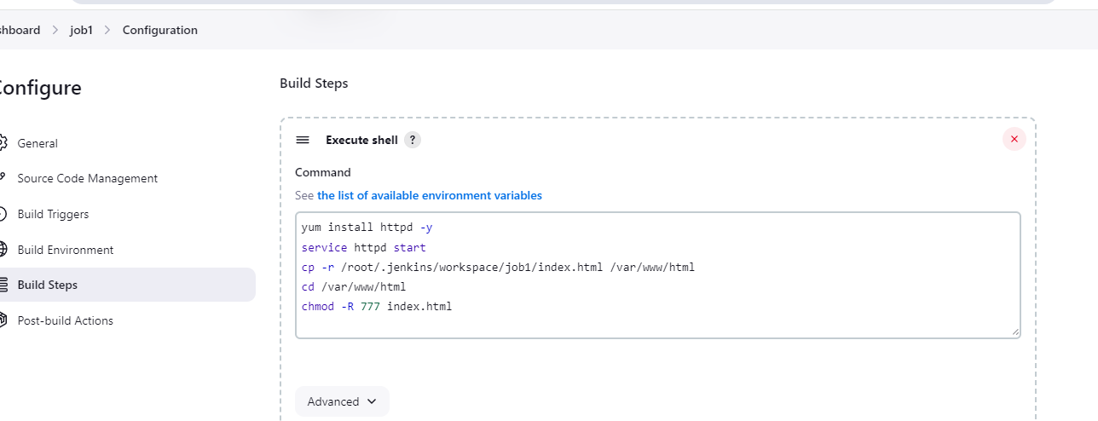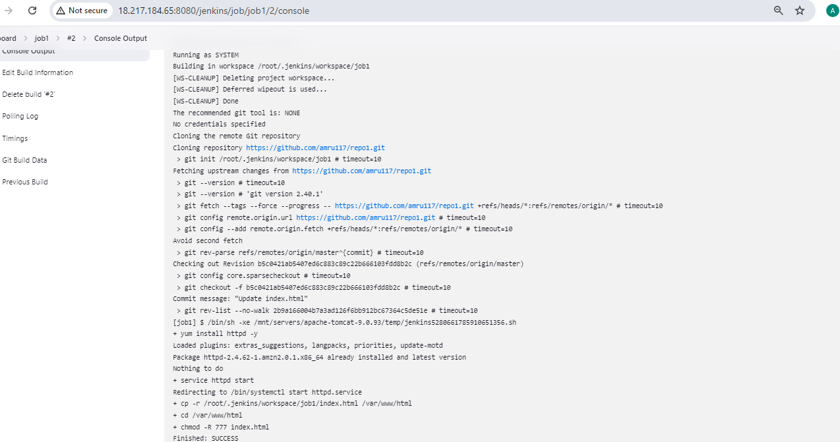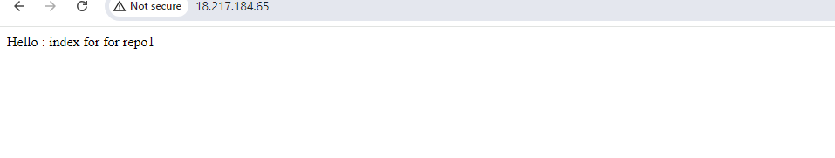2.created the job2 and added webhooks for the repo2 also deleted the index file of repo1 when we run the job2 and made changes into repo and again run the job.

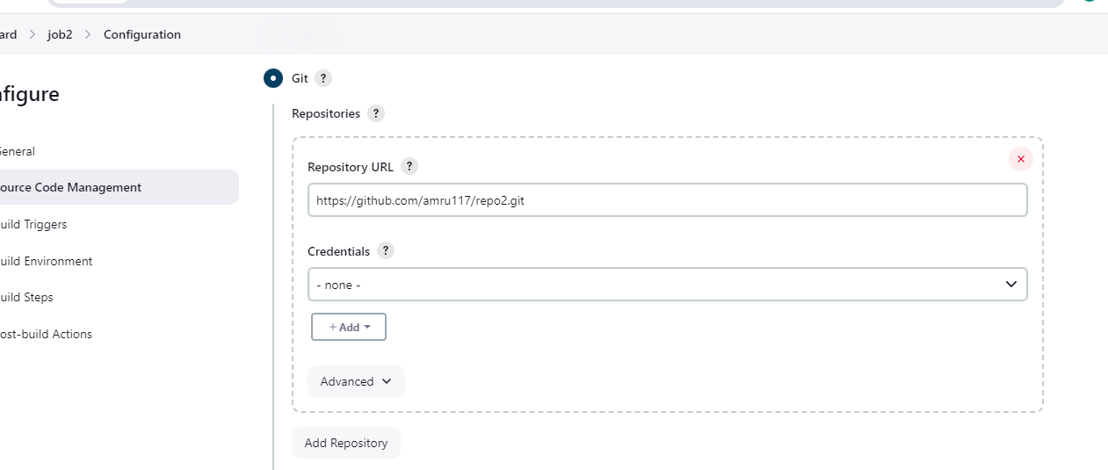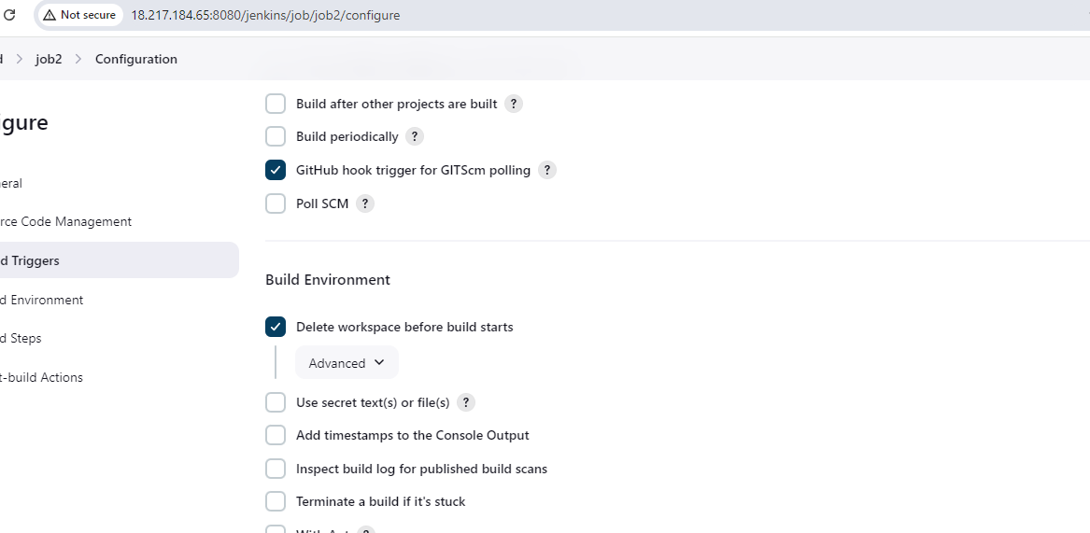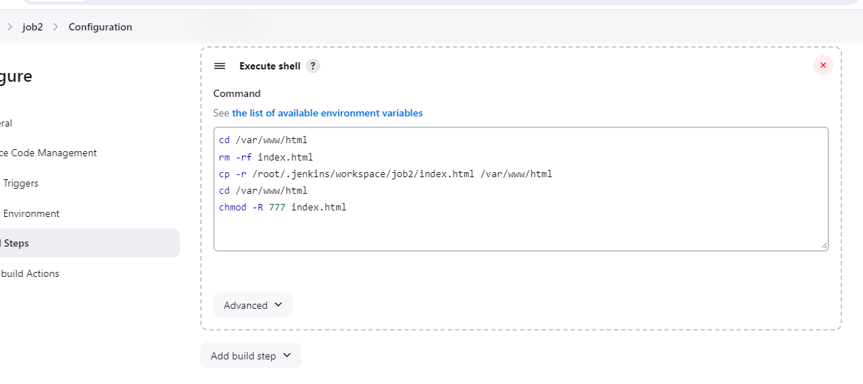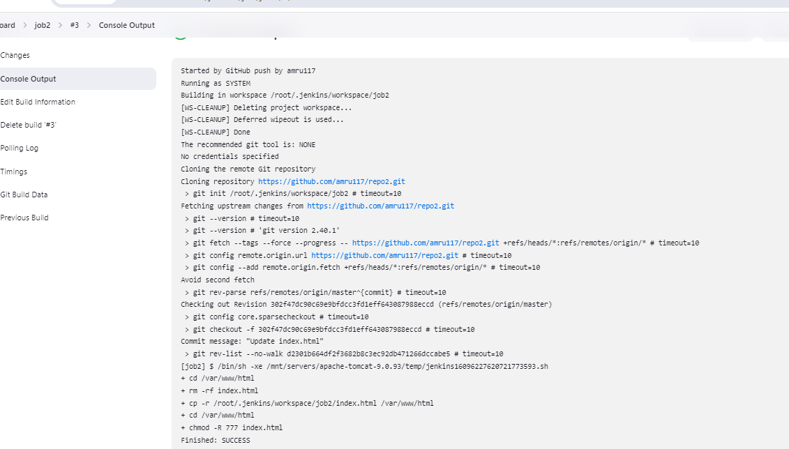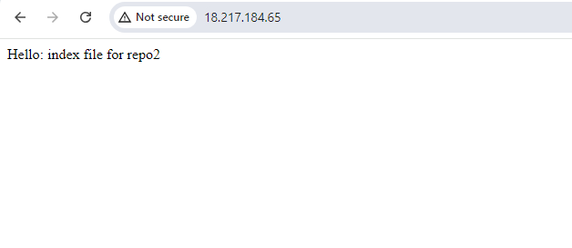3.created the job3 for repo3 and added webhooks for this repo3 also.Deployed index file in repo3 on http and deleted the previous index present on the server.

